GUIDE FOR INCOMING EXCHANGE STUDENTS

WELCOME TO LAHTI AND SALPAUS FURTHER EDUCATION!

Lahti is a city of 120,000 inhabitants, and it is situated 100 kilometres north of Helsinki.
The centre of Lahti lies in a bowl-like valley formed by the Salpausselkä Hills. Located by the Lake Vesijärvi it is a gateway to the Finnish Lake District. Inland waterways dominate the landscape here.

Lahti is an industrial and commercial centre of the region. It is well known worldwide for furniture, garments, electronics and heavy machinery and nation-wide for beer, soft drinks, bakery products and many others.

Salpaus has 5 campuses: 3 in Lahti city, 1 in Heinola and 1 in Asikkala.

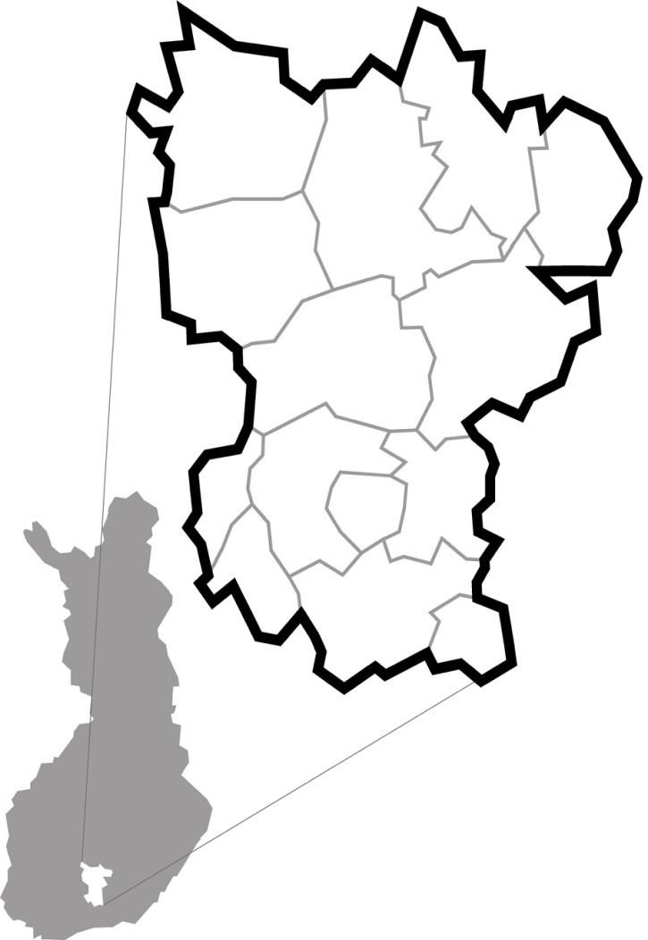

Kuhmoinen

Sysmä

Hartola

Pertunmaa

Padasjoki

Heinola

Asikkala

Nastola

Hollola

Lahti

Orimattila

Artjärvi

Hämeenkoski

Kärkölä

Tourist information office

www.lahti.fi/en

http://www.lahtiregion.fi/en

LAHTI REGION OY
Aleksanterinkatu 18 tel. +358 0207 281 760
info@lahtiregion.fi

Arrival in Lahti from the Helsinki airport

There’s a train connection from the airport to the city of Lahti
Check the train timetables: https://www.vr.fi/en/
Earliest train leaves at about 6 am and the latest at midnight. Trains leave every hour, and the prices vary from 10€ to 16€ for one adult. During the train trip there is a change at Tikkurila station.

Accommodation in Lahti

Forenom and Opiston Kunkku are the main accommodation service providers offering short-term accommodation in Lahti.
You can choose your own accommodation and are responsible for making the reservations yourself.

Forenom Accommodation Service
Tel. 09-4250050, https://www.forenom.com/accommodation/Lahti/

The reservation should be made at least one month prior to the stay. It is also possible to make the reservation less than one month before the beginning of the stay, but in that case Forenom cannot necessarily arrange the budget price and the price can be higher.

Forenom has both aparthotel type accommodation and some separate apartments. Aparthotel unit is on Aleksanterinkatu street and apartments are on Rauhankatu street. In the same building though.

There are rooms for one, two, three and four. Some rooms for 3 and 4 have also a kitchenette.

All rooms have a bathroom with a shower. Every room has TV, fridge, microwave, coffeemaker, electric kettle, hair dryer and basic tableware. Rooms also have an iron and ironing board. For the full home-away-from-home experience, you can choose a room with a kitchenette. These have utensils and equipment for light cooking. Prices always includes fast Wi-Fi and final cleaning.

Opiston Kunkku Accommodation service
https://www.opistonkunkku.com/majoitus

Opiston Kunkku is offering accommodation in Lahti city center and has both hotel and hostel type of accommodation also for longer stay.
Unfortunately, website is only in Finnish.

Information on room types and prices can be found under ”Majoitus”

- Hotel rooms (Pilvilinna-hostellihuone in the price list)

Hotel rooms are for 1-4 person depending on the room type.

- Hostel rooms (Hostellihuone in the price list)

Hostel rooms are either single rooms or double rooms with a washing sink. Shared toilets and shower, and a small kitchen & lounge with 72” TV on each floor.

Breakfast is optional in both room types.

Other hostels in Lahti:

Patria Hostel
Vesijärvenkatu 3
15100 Lahti
Tel. 03 -7823783
http://www.patriahostel.fi/

AirbnB accommodation is also possible

Meals

Lunches

A) Students studying in Salpaus study groups:
full meal lunch at school cafeterias in campuses (tutoring teacher at the department will organize upon arrival)

B) Students in company training: lunch according to company arrangements

Other meals

Ask from Forenom if there is a shared kitchen which can be sued for cooking meals
At Opiston Kunkku, there is a shared kitchen on each floor where meals can be prepared. Some dishes can be found there also. More dishes can bought at the flea markets.

Mobile phones

For EU citizens:
Phone calls, SMS and data usage should cost the same as in your home country in the EU. Note that your mobile operator should explicitly tell you if you have a roaming data limit.
If you continue roaming more than you are at home, your operator may start applying a small charge to your roaming consumption.

For non-EU citizens:
Before arrival, check your operator on how your mobile phone works in Finland. You can buy a pre-paid mobile phone SIM card available at R-kioski or at mobile operator’s shops.
There are certain limitations that the Finnish pre-paid cards do not function in all the newest phone models.

The beginning of the on-the-job learning (practical training/ internship)
Your tutor teacher at Salpaus and the workplace supervisor will handle any practical issues related to the on-the-job placement. Your tutor teacher will take you on the first day to the training place and visit your training place (as agreed).

ISIC

ISIC-card is an international student card, which gives students discounts and other benefits around the world. The card gives the holder the status of international student giving discounts i.e. for accommodation services, flying tickets and various events and museums. Many flying companies grant discounts even for the holders´ husband/wife. Detailed information of the benefits you can find in web-address www.isic.org.
Please order the ISIC-card before your arrival in Finland.

Health
There are public health care centres (in Finnish: terveyskeskus) and hospitals. You normally have to make an appointment to see a nurse or a doctor.

IMPORTANT: European health care card gives you public health care at the same price as Finnish inhabitants and the card is valid in every EU-member country. Please contact your own health care administrator to get the card before you leave; the card is free of charge.

Read detailed instructions here:
https://www.lahti.fi/en/housing-and-environment/social-and-health-services/

In GENERAL EMERGENCY dial 112

Insurance
All students are responsible for their own insurance arrangements, and we strongly recommend you to take a comprehensive insurance for your stay in Finland. Before leaving your home country, please check your travel and health insurance with your school.
Remember to bring the valid insurance policy with you.

EU citizens: European Health Insurance Card & private insurance
Students from the EU/EEA countries are entitled to public health services in Finland, if they are covered by health insurance in their own country. A European Health Insurance Card is needed for public health services in Finland. The card ensures that you will get the same access to public sector health care as the local residents (e.g. a doctor, a pharmacy, a hospital or a health care centre), covering mainly emergency treatment in the event of an illness or injury, and other medically necessary treatment. Any costs you incur outside the system you will have to pay on your own.
Citizens of the EU/EEA countries must also have a private insurance in addition to the European Health Insurance Card. The European Health Insurance Card is not valid during your travels to and from Finland and during any excursions to a third country outside of the EU.
More information is available on European Commission web pages.

Students outside the EU: private insurance
Students from outside the EU/EEA must have private insurance to cover the duration of the visa / residence permit and the Schengen area before they enter Finland. The insurance must cover the treatment and health care provided by municipal health care services, cases of illness or accident, and include travel costs to home country as well as liability insurance.
Taking insurance from an international insurance company is recommended. For travel outside Finland, please make sure the insurance is valid in these countries as well.
More information is available on Finnish Immigration Service web pages.

Libraries

In order to borrow books or other material, you need to get yourself a library card from the library you wish to use.

A card is needed for the Lahti Main Library which provides all kind of literature from novels to science. You need to fill in a form and show some proof of identification (e.g. passport) to get the library card.

In addition to printed material the libraries also offer PCs with modern applications for information search, quiet study places for independent studying as well as rooms for group work. You can get the services free of charge.

Lahti Main Library, Kirkkokatu 31, tel. + 358 3 812 511. Provides general literature, newspapers and periodicals, and music to all residents of Lahti, including exchange students, free of charge. https://lastu.finna.fi/?lng=en-gb.

Local bus transportation

Operating company: Lahden Seudun Liikenne, LSL https://www.lsl.fi/in-english/

Tickets and Prices
The ticket prices are based on traveling zones and customer groups. Check the prices on the website.
Customer groups
Children (7-16 year olds)
Young people (17-19 year olds, 30 % discount for value and season tickets)
Students* (only for full-time students, studying min. 8 months)
Adults (over 20 years (no discount)
Seniors (over 65 years old)

Three ticket choices year 2023:
- Season ticket (30 days) Waltti card required

- Value ticket
You can load value (0,65–500 €) to a personal Waltti card. When paying by value, the price of a ticket is approximately 25-35% lower than for a corresponding single ticket paid in cash. A single ticket about 2 €

- Mobile ticket
LSL offers a mobile app, which can be used to buy single tickets and 24 hour day tickets for adults and children (aged 7-16). NOTE: no students or young people discounts available. A registered user can choose different payment methods, such as a bank or credit cards. An unregistered user is charged on the mobile phone bill. A single ticket is 3 € one-way.

- Single ticket
You can purchase single tickets with cash from the bus driver. When buying a ticket from the driver, please have small change (preferably the exact amount) to pay for your fare. Drivers do not have to accept notes larger than 20 euros. Debit and credit cards are not accepted on buses. A single ticket bought at the bus is about 3,5€.

Waltti travel card info
You can pay all your local and regional LSL bus transport fares with a Waltti travel card. Personal Waltti card can only be used by the card owner.
The easiest way to buy a personal travel card is from the online Waltti web shop (link on the web site), where you can also load a ticket product onto the card. You can also purchase a card from customer service or other sales points (address: Trio shopping center “Palvelutori Service Centre” Vesku-aukio, 2nd floor, Aleksanterinkatu 18, 15140 Lahti)

Shops

Common food stores:
S-Market
K-Market
Lidl
Alepa

Shopping malls:
Trio is a large shopping centre offering a wide range of clothing and shoe shops, cafes, restaurants, etc.
Karisma
Valo
Syke

Kiosks:
R-Kioski

Things to do in Lahti

Messilä
The biggest ski center in Southern Finland has totally 10 slopes.
In the same yard you can find ski rental, ski school, outdoor activity company and on summer time golf course.

https://messila.fi/en/messilan-rinteet-2/hiihtokoulu/aktiviteetit

https://www.ski.fi/en/resorts/messila/

Swimming pools and outdoor swimming pool
In Lahti, you can do water sports at the public indoor swimming pools of Nastola, Saksala, Kivimaa and Lahti. Enjoy summer days in outdoor pool Maauimala.
https://www.lahti.fi/en/leisure-and-sports/sports-services/swimming/

Lahti Harbour | Pikku-Vesijärvi Park
Show on map
Pikku-Vesijärvi Park is a green oasis just outside the city center. It provides a wonderful venue for fitness events,pop ups, small music festivals and exercise for example. The area comprises a musical fountain, outdoor exercise equipment, grass fields and a one-kilometer long footpath.

Lahti Sports Centre
Show on map
Internationally known Lahti Sports Centre is the heart of the ski games. At the sports centre are located the ski jump towers, restaurant Voitto, ice hockey arena, ski museum, outdoor swimming pool and much more. During the wintertime there are ski trails on the area and during the summertime outdoor hiking trails.

Lahti Sports Centre | Ski Museum
Show on map
The Ski Museum is located in the Sports Centre, close to the ski jumps, only a short walk from Lahti city centre.

Lanu Sculpture Park
Show on map
Lanu Sculpture Park is situated in Kariniemi Park, and is an officially protected grove hill near the centre of Lahti. Amidst the wide range of luxuriant vegetation are works in concrete by sculptor Olavi Lanu of Lahti.

Malski
Show on map
Malski is a center for culture and museum experiences in the city centre of Lahti. The centre is located in a historic brewery building from 1912.

Malva museum of visual arts: art, design, posters and culture
Open on Tuesday-Sunday, Monday closed
www.malvamuseo.fi
Malski's restaurant world includes Malskin Bistro restaurant, Kahiwa Coffee Roasters and Ant Brew brewery pub. Kahiwa and Ant Brew also host tastings.
Lahti Harbour | Sibelius Hall Congress and Concert Centre
Show on map
The impressive wooden concert and congress centre was built on the Vesijärvi waterfront in spring 2000. Sibelius Hall combines industrial history with modern, wooden architecture. Its beautiful Main Hall is known internationally for its excellent acoustics. A masterpiece of modern wood architecture, combining the historic carpentry factory with modern architecture. Lahti Symphony Orchestra concerts provide a way to enjoy the wonderful acoustics of the main hall. The repertoire also includes light music and stars from the world of entertainment. Finlandia club hosts gigs from Finland's finest in rock, pop, hiphop and heavy metal.

Welcome to Lahti!
Hope you enjoy your stay with us!

